***JAVA CODE FOR EVEN AND ODD NUMBERS***

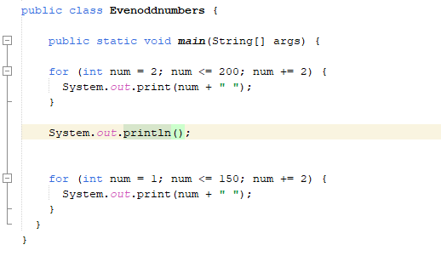

**Figure 1**

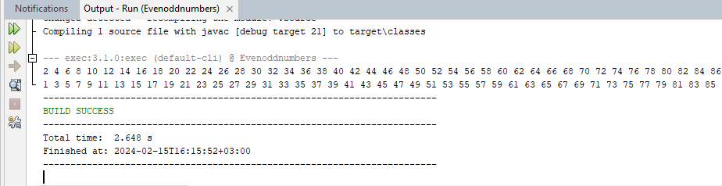

**Figure 2**

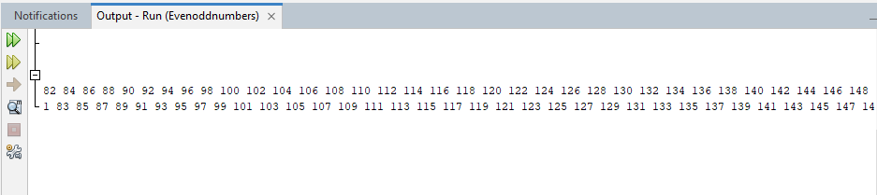

**Figure 3**

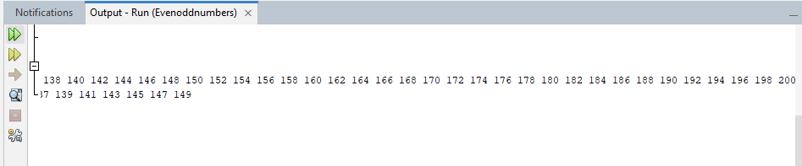

**Figure 4**